Mata kuliah : Pemrograman Visual .NET
Dosen : Tony Wijaya, S.Kom

Project 11 : MenuStrip, StatusStrip, dan RichTextBox

- Mulai project baru
- Click form → Properties
FormBorderStyle → Sizable
Text → Notepad sederhana
Name → frm_notepadSederhana
StartPosition → CenterScreen
- Click ToolBox → MenuStrip → (Click ke form)
- Click Type Here → MenuItem
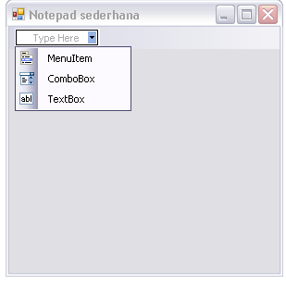
- Click ToolStripMenuItem1 → Properties
Text → &File
Name → menu_file
- Click Type Here di bawah menu File → MenuItem
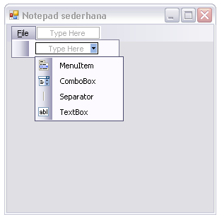
- Click ToolStripMenuItem → Properties
Text → T&utup
Name → menu_fileTutup
ShortcutKeys → Alt+F4
- Click ToolBox → StatusStrip → (Click ke form)
- Click icon (tanda new item) pada StatusStrip1 → StatusLabel
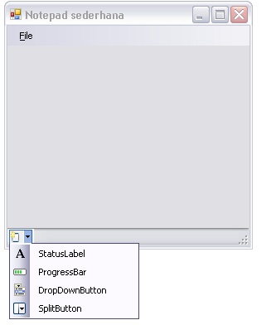
- Click ToolStripStatusLabel1 → Properties
Spring → True
TextAlign → MiddleLeft
Name → status_lbl
- Click ToolBox → RichTextBox → (Click ke form)
- Click RichTextBox1 → Properties
Name → rtb_notepad
Dock → Fill
- Double click File → Tutup
Private Sub menu_fileTutup_Click(ByVal sender As System.Object, ByVal e As System.EventArgs) Handles menu_fileTutup.Click
Dim msg As String
Dim dr As DialogResult

msg = "Apakah anda yakin untuk menutup program?"
dr = MessageBox.Show(msg, Me.Text, MessageBoxButtons.OKCancel, MessageBoxIcon.Question)

If dr = Windows.Forms.DialogResult.OK Then Me.Close()
End Sub
- Tekan F5 (play)

Project 12 : SaveFileDialog

- Lanjutkan project11
- Right click pada File → Tutup → Insert → Separator
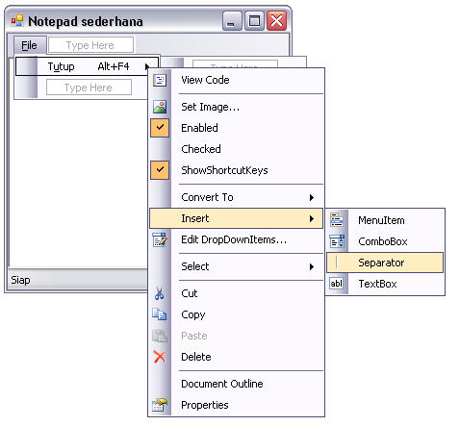
- Right click pada Separator → Insert → MenuItem
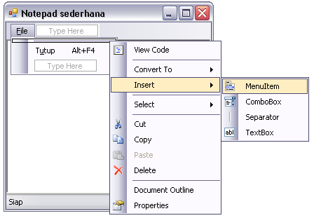
- Click ToolStripMenuItem1 → Properties
Text → &Simpan…
Name → menu_fileSimpan
ShortcutKeys → Ctrl+S
- Click ToolBox → SaveFileDialog → (Click ke form)
- Click SaveFileDialog1 (terletak di bawah) → Properties
Title → Simpan
DefaultExt → txt
Filter → Text files (*.txt)|*.txt
InitialDirectory → My Documents
Name → sfd_notepad
- Double click menu File → Simpan
Sebelum mengetikkan code, terlebih dahulu meng-impor class System.IO di luar class (bagian paling atas code) dengan mengetikkan Import System.IO
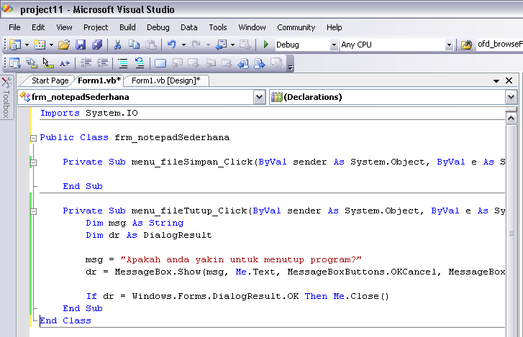
Private Sub menu_fileSimpan_Click(ByVal sender As System.Object, ByVal e As System.EventArgs) Handles menu_fileSimpan.Click
Dim fs As FileStream
Dim sw As StreamWriter
Dim msg As String

If sfd_notepad.ShowDialog() = Windows.Forms.DialogResult.Cancel Then Exit Sub

fs = New FileStream(sfd_notepad.FileName, FileMode.Create, FileAccess.Write)
sw = New StreamWriter(fs)
sw.Write(rtb_notepad.Text)
sw.Flush()
sw.Close()
fs.Close()

msg = "File telah disimpan ke : " + sfd_notepad.FileName
status_lbl.Text = msg
End Sub
- Tekan F5

Project 13 : OpenFileDialog

- Lanjutkan project12
- Right click pada menu File → Simpan → Insert → MenuItem
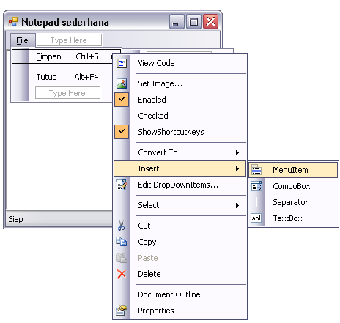
- Click pada ToolStripMenuItem1 → Properties
Text → &Buka…
Name → menu_fileBuka
ShortcutKeys → Ctrl+O
- Click ToolBox → OpenFileDialog → (Click ke form)
- Click OpenFileDialog1 (terletak di bawah) → Properties
Title → Buka
DefaultExt → txt
Filter → Text files (*.txt)|*.txt
InitialDirectory → My Documents
Name → ofd_notepad
- Double click menu File → Buka
Private Sub menu_fileBuka_Click(ByVal sender As System.Object, ByVal e As System.EventArgs) Handles menu_fileBuka.Click
Dim fs As FileStream
Dim sr As StreamReader
Dim msg As String

If ofd_notepad.ShowDialog() = Windows.Forms.DialogResult.Cancel Then Exit Sub

fs = New FileStream(ofd_notepad.FileName, FileMode.Open, FileAccess.Read)
sr = New StreamReader(fs)
rtb_notepad.Text = sr.ReadToEnd()
sr.Close()
fs.Close()

msg = "File telah dibuka dari : " + ofd_notepad.FileName
status_lbl.Text = msg
End Sub
- Tekan F5

Project 14 : ShortcutKeys

- Lanjutkan project13
- Click pada bagian kosong di sebelah menu File
- Setelah muncul Type Here, click MenuItem
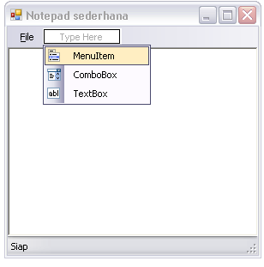
- Click ToolStripMenuItem1 → Properties
Text → &Edit
Name → menu_edit
- Click Type Here di bawah menu Edit → MenuItem
- Click ToolStripMenuItem1 → Properties
Text → C&ut
Name → menu_editCut
ShortcutKeys → Ctrl+X
- Click Type Here di bawah menu Cut → MenuItem
- Click ToolStripMenuItem1 → Properties
Text → C&opy
Name → menu_editCopy
ShortcutKeys → Ctrl+C
- Click Type Here di bawah menu Copy → MenuItem
- Click ToolStripMenuItem1 → Properties
Text → &Paste
Name → menu_editPaste
ShortcutKeys → Ctrl+V
- Double click menu File → Cut
Private Sub menu_editCut_Click(ByVal sender As System.Object, ByVal e As System.EventArgs) Handles menu_editCut.Click
rtb_notepad.Cut()
End Sub
- Double click menu File → Copy
Private Sub menu_editCopy_Click(ByVal sender As System.Object, ByVal e As System.EventArgs) Handles menu_editCopy.Click
rtb_notepad.Copy()
End Sub
- Double click menu File → Paste
Private Sub menu_editPaste_Click(ByVal sender As System.Object, ByVal e As System.EventArgs) Handles menu_editPaste.Click
rtb_notepad.Paste()
End Sub
- Tekan F5

Project 15 : FontDialog

- Lanjutkan project14
- Click pada bagian kosong di sebelah menu Edit
- Setelah muncul Type Here, click MenuItem
- Click ToolStripMenuItem1 → Properties
Text → F&ormat
Name → menu_format
- Click Type Here di bawah menu Format → MenuItem
- Click ToolStripMenuItem1 → Properties
Text → Font
Name → menu_formatFont
- Click ToolBox → FontDialog → (Click ke form)
- Click FontDialog1 (di bawah) → Properties
Name → fd_notepad
- Double click menu Format → Font
Private Sub menu_formatFont_Click(ByVal sender As System.Object, ByVal e As System.EventArgs) Handles menu_formatFont.Click
If fd_notepad.ShowDialog() = Windows.Forms.DialogResult.Cancel Then Exit Sub

rtb_notepad.Font = fd_notepad.Font
End Sub
- Tekan F5

